**דוח מעבדה מספר 2**

מגישים:

סער ויקטור – 312392822

אילון בן סימון – 312162951

תרגיל 1

;

; hello4.asm - Conditional response.

;

.MODEL SMALL

.STACK 100h

.DATA

TimePrompt DB 'Is it after 12 noon (y/n)?',13,10,':$'

GoodAfternoonMessage DB 13,10

DB 'Good afternoon, world!',13,10,'$'

GoodMorningMessage DB 13,10

DB 'Good morning, world!',13,10,'$'

**ErrorMsg DB 13,10, 'Input Error!',13,10,'$'**

;

;

.CODE

ProgStart:

MOV AX,@DATA ; DS can be written to only through a register

MOV DS,AX ; Set DS to point to data segment

MOV AH,9 ; Set print option for int 21h

MOV DX,OFFSET TimePrompt ; Set DS:DX to point to TimePrompt

INT 21h ; Print TimePrompt

MOV AH,1 ; DOS get character function #

INT 21h ; Get a single character from keyboard

CMP AL,'y' ; AL has input. Compare with 'y'

JE IsAfternoon ; If AL = 'y' then go to IsAfternoon

CMP AL,'Y' ; Compare with 'Y'

JE IsAfternoon ; If AL = 'Y' then go to IsAfternoon

**CMP AL, 'n'**

**JE IsMorning**

**CMP AL, 'N'**

**JE IsMorning**

**MOV DX, OFFSET ErrorMsg**

**JMP DisplayGreeting**

IsMorning:

MOV DX,OFFSET GoodMorningMessage ; Point display message to morning

JMP DisplayGreeting ; Avoid following code

IsAfternoon:

MOV DX,OFFSET GoodAfternoonMessage ; Point display message to afternoon

DisplayGreeting:

MOV AH,9 ; Set print option for int 21h

INT 21h ; Print chosen message

MOV AH,4Ch ; Set terminate option for int 21h

INT 21h ; Return to DOS (terminate program)

END ProgStart

פלטים:

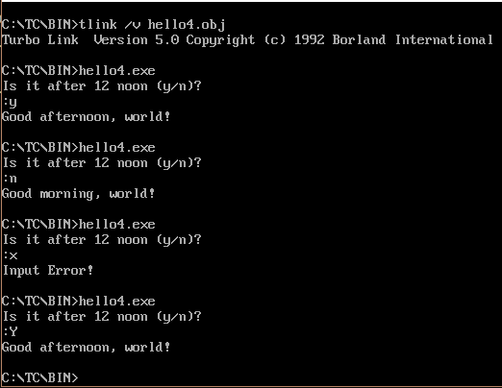

תרגיל 2

;

; Lab2.asm - Conditional response.

;

.MODEL SMALL

.STACK 100h

.DATA

DisplayString DB 'Enter your grade',13,10,'$'

DisplayGradeA DB 13,10, 'Very Good', 13,10, '$'

DisplayGradeB DB 13,10, 'Good', 13,10, '$'

DisplayGradeC DB 13,10, 'Not Good', 13,10, '$'

DisplayGradeF DB 13,10, 'Very Bad. You Failed', 13,10, '$'

DisplayErrorMsg DB 13,10, 'Input Error!!!', 13,10, '$'

;

;

.CODE

ProgStart:

MOV AX,@DATA ; DS can be written to only through a register

MOV DS,AX ; Set DS to point to data segment

MOV AH,9 ; Set print option for int 21h

MOV DX,OFFSET DisplayString ; Set DS:DX to point to DisplayString

INT 21h ; Print DisplayString

MOV AH,1 ; DOS get character function #

INT 21h ; Get a single character from keyboard

CMP AL,'A' ; AL has input. Compare with 'A'

JE GradeA ; If AL = 'A' then go to GradeA

CMP AL,'B' ; Compare with 'B'

JE GradeB ; If AL = 'B' then go to GradeB

CMP AL, 'C' ; Compare with 'C'

JE GradeC ; If AL = 'C' then go to GradeC

CMP AL, 'F' ; Compare with 'F'

JE GradeF ; If AL = 'F' then go to GradeF

MOV DX, OFFSET DisplayErrorMsg

JMP DisplayGrades

GradeA:

MOV DX,OFFSET DisplayGradeA ; Point display message to grade A

JMP DisplayGrades ; Avoid following code

GradeB:

MOV DX,OFFSET DisplayGradeB ; Point display message to grade B

JMP DisplayGrades ; Avoid following code

GradeC:

MOV DX,OFFSET DisplayGradeC ; Point display message to grade C

JMP DisplayGrades ; Avoid following code

GradeF:

MOV DX,OFFSET DisplayGradeF ; Point display message to grade F

DisplayGrades:

MOV AH,9 ; Set print option for int 21h

INT 21h ; Print chosen message

MOV AH,4Ch ; Set terminate option for int 21h

INT 21h ; Return to DOS (terminate program)

END ProgStart

פלטים:

